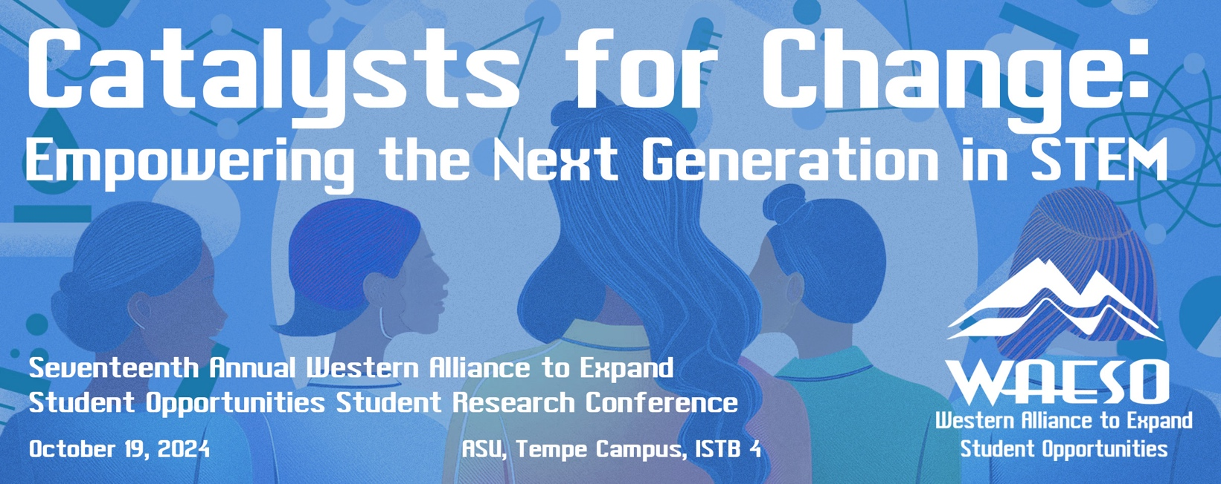



**TIME/LOCATION SESSION**

8:00 AM–9:00 AM Registration / Continental Breakfast

**1st Floor Gallery**

9:00 AM–9:15 AM **Opening Remarks**

**Room #240**

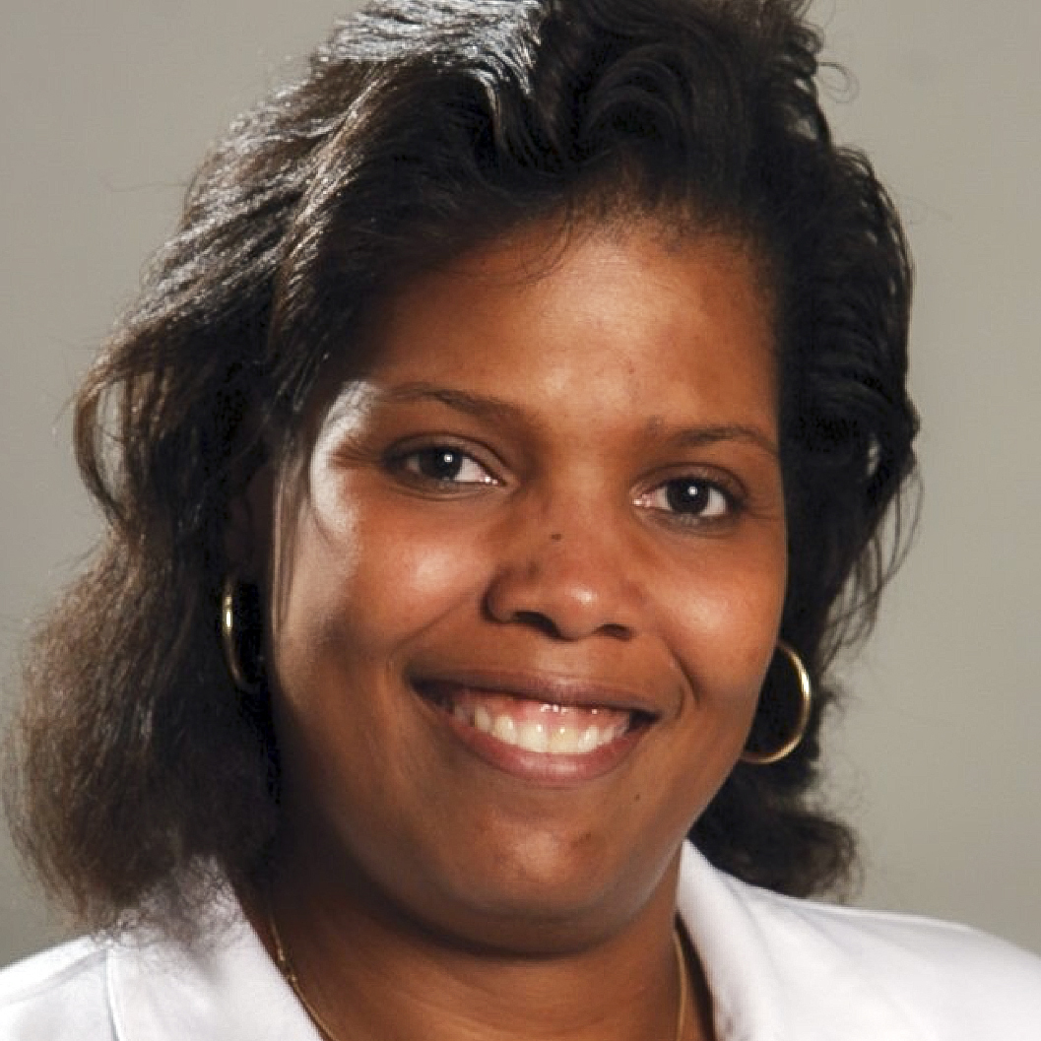

**[Jean Andino, Ph.D., P.E.](https://whova.com/embedded/speaker_detail/asrc_202203/21407021/)**

**Director**

Western Alliance to Expand Student Opportunities (WAESO)

**Associate Professor**

School for Engineering of Matter, Transport and Energy (SEMTE), Arizona State University

Dr. Jean Andino, WAESO Program Director, will open

the conference and welcome attendees.

9:15 AM–10:30 AM **Navigating the Academic Journey:**

**Room #240** **Perspectives from Four Trailblazers**

  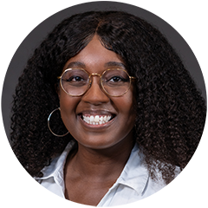

## [Joana Sipe, Ph.D.](https://search.asu.edu/profile/1834619)

**Assistant Professor**

School of Integrated Engineering,

Arizona State University

[**Meli’sa Crawford, Ph.D.**](https://profiles.ucr.edu/melisa.crawford)

**Postdoctoral Researcher**

Biomedical Sciences Department,

University of California, Riverside

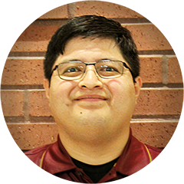 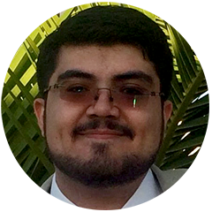

[**Andre Luna Magdaleno**](https://search.asu.edu/profile/2072183)

**Graduate Student**

Environmental Engineering

**Graduate Research Associate**

School of Sustainable Engineering and the Built Environment, Arizona State University

[**Roberto Martinez**](https://search.asu.edu/profile/3511146)

**Doctoral Student**

Chemical Engineering

**Graduate Research Associate** School for Engineering of Matter, Transport and Energy,

Arizona State University

Join a panel discussion featuring accomplished individuals

in STEM who will share their experiences and advice on

pursuing a successful academic career.

10:30 AM–10:45 AM Break

10:45 AM–11:15 AM **From Student to Scholar:**

**Room #240 Why You Should Consider Doctoral Education**

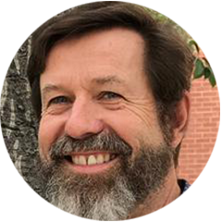 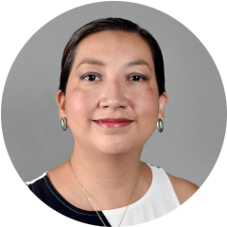

[**Otakuye Conroy-Ben, Ph.D.**](https://search.asu.edu/profile/2752178)

**Associate Professor**

School of Sustainable Engineering and the Built Environment,

Arizona State University

[**Frans Tax, Ph.D.**](https://mcb.arizona.edu/profile/frans-tax)

**Associate Dean**,

Student Affairs, Diversity and

Inclusion, UA Graduate College

**Professor**,

Department of Molecular and Cellular Biology, The University of Arizona

Learn about the benefits and opportunities of pursuing

a doctoral degree from experts in the field.

11:15 AM–12:00 PM **How to Succeed in Graduate School**

**Room #240**

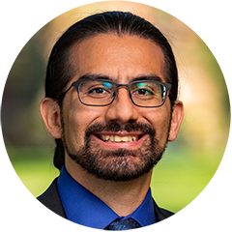

[**Mauro Rodriguez Jr., Ph.D.**](https://vivo.brown.edu/display/mrodri97)

**Assistant Professor**

School of Engineering,

Brown University

Gain valuable insights on navigating graduate school

and the key differences between Master's and PhD

programs.

12:00 PM–1:00 PM Lunch / Networking

**3rd Floor Crater Carpet**

1:00 PM–1:45 PM **Graduate School Application and Funding**

**Room #240**

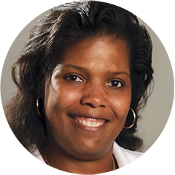

[**Jean Andino, Ph.D., P.E.**](https://whova.com/embedded/speaker_detail/asrc_202203/21407021/)

**Director**

Western Alliance to Expand Student Opportunities (WAESO)

**Associate Professor**

School for Engineering of Matter, Transport and Energy (SEMTE), Arizona State University

Get expert advice on the graduate school application

process and explore funding opportunities.

2:00 PM–5:00 PM **Thriving in STEM: Learning the Hidden Dimensions**

**Room #296 and Silent Language of Academic Culture**

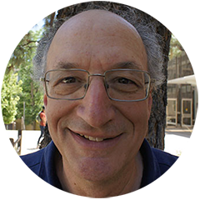  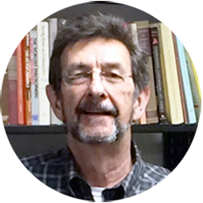

## [Gary Weissmann, Ph.D.](https://aspire.unm.edu/about/people/profile/gary-weissmann.html)

**Professor**

Earth and Planetary Sciences,

The University of New Mexico

[**Roberto A. Ibarra, Ph.D.**](https://sociology.unm.edu/people/faculty%20profile/Roberto%20A.%20Ibarra.html)

**Associate Professor Emeritus**

Department of Sociology,

The University of New Mexico

This workshop will provide you with a new framework for understanding and navigating academic culture. By

introducing Multicontext Theory (MCT), you will gain insights

into how your personal cultural background may influence

your academic experiences and explore ways to thrive in the

inclusive research environment.

5:15 PM–5:30 PM **Closing Remarks**

**Room #240**

[**Jean Andino, Ph.D., P.E.**](https://whova.com/embedded/speaker_detail/asrc_202203/21407021/)

**Director**

Western Alliance to Expand Student Opportunities (WAESO)

**Associate Professor**

School for Engineering of Matter, Transport and Energy (SEMTE), Arizona State University

Dr. Jean Andino will adjourn this year's conference

and invite all participants to join us again in 2025!

5:30 PM–6:00 PM Participation Verification / Networking

**1st Floor Gallery**

Complete the conference participation verification

process and enjoy additional networking opportunities

with fellow attendees.